International Islamic
University Islamabad


Assingment :- “Real state management system ERD diagram”
Submitted by:-
omer jabbar
4768_FOC_BSSE_F23A
Mesum Abbas
4736_FOC_BSSE_F23A
Submitted to:-
Dr shakir
DataBase Management system (DBMS)

Real state management system:-

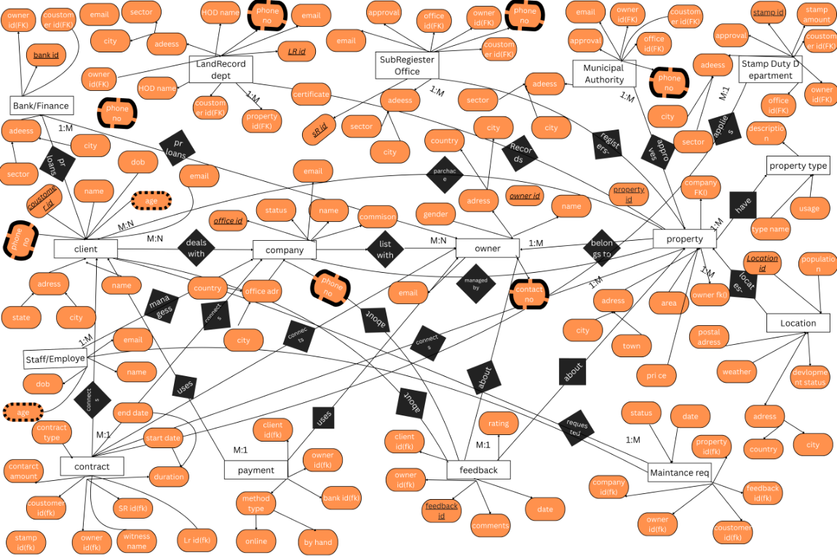

ERD Documentation – Real Estate Management System:-

1. Introduction
For our project, I designed an Entity-Relationship Diagram (ERD) for a real estate management system. The diagram shows how all the main parts of the system are connected, like clients, owners, properties, real estate companies, and all the transactions.
I used Chen notation for the diagram, which means: rectangles for entities, diamonds for relationships, and keywords describing the connection. This system will help manage everything clearly and make it easier to implement in a database later.

2. Entities
There are 16 main entities in the system. Here’s what each one represents:
Client – The person looking to buy or rent a property.
Owner – Someone who owns a property and wants to list it.
Real_Estate_Company – Agencies or companies that manage properties and clients.
Staff / Employee – Employees working in the company who handle daily operations.
Location – The area or city where the property is located.
Property – The actual real estate item for sale or rent.
Property_Type – Type of property, like House, Apartment, or Commercial.
Contract / Agreement – Junction table connecting clients, owners, companies, and properties.
Payment – Records payments made for a contract
Feedback / Review – Reviews given by clients about properties, owners, or companies.
Maintenance_Request – Requests for property maintenance, assigned to staff.
Land_Records_Department – Keeps official property records.

Sub_Registrar_Office – Handles the legal registration of properties and contracts.

Municipal_Authority – Approves zoning, development, and property taxes.

Stamp_Duty_Department – Takes care of taxes and stamp duty for property contracts.

Bank / Finance_Office – Provides loans to clients or owners.

All these entities are strong entities, which means they can exist on their own in the system.

3. Relationships
Here’s how the entities connect. In the ERD, I used diamonds with keywords to show what each relationship means.
Entities | Keyword | Type | Notes
Client – Real_Estate_Company | deals with | M:N | Many clients can deal with many companies. This is handled through Contract / Agreement.
Owner – Real_Estate_Company | lists with | M:N | Owners can list properties with multiple companies, also handled via Contract / Agreement.
Real_Estate_Company – Staff | employs | 1:M | One company employs many staff members.
Property – Owner | belongs to | M:1 | Each property belongs to one owner.
Property – Location | located at | M:1 | Each property is in a location.
Property – Property_Type | is of type | M:1 | Each property has one type.
Property – Real_Estate_Company | managed by | M:1 | Each property is managed by one company.
Client – Property | buys/rents | M:N | Clients can buy or rent multiple properties, and a property can be seen by many clients.
Contract / Agreement – Client / Owner / Company / Property | connects | M:1 | Each contract connects a client, owner, company, and property.
Payment – Contract / Client / Owner | made for | M:1 | Each payment is linked to a contract and records the transaction.
Feedback / Review – Client / Owner / Company / Property | about | M:1 | Feedback is given by clients about properties, owners, or companies.
Maintenance_Request – Property / Staff / Client | requested for | M:1 | Requests for maintenance are assigned to staff.
Bank / Finance_Office – Client / Owner | provides loan to | M:1 | Banks can give loans to clients or owners.
Land_Records_Department – Property | records | 1:M | Keeps official property records.
Sub_Registrar_Office – Contract / Property | registers | 1:M | Handles legal registration of properties and contracts.
Municipal_Authority – Property / Location | approves | 1:M | Approves zoning, development, and property-related taxes.
Stamp_Duty_Department – Contract | applies | 1:M | Applies taxes and verifies stamp duty for each contract.
Extra/Optional Relationships (for extra marks or clarity):
Entities | Keyword | Notes
Staff – Maintenance_Request | handles | 1:M
Bank / Finance_Office – Property | finances | 1:M
Location – Municipal_Authority | under jurisdiction of | 1:M

4. Design Decisions
M:N relationships (like Client ↔ Company, Owner ↔ Company, Client ↔ Property) are handled with Contract / Agreement as a junction table. This avoids putting foreign keys directly in Client, Owner, or Company tables.
There are no weak entities because every entity can exist independently.

Property_Type is a regular entity, not weak, because types like “Apartment” exist even without a specific property.
Followed Chen notation, with rectangles for entities, diamonds for relationships, and keywords describing them.

5. Conclusion
The ERD shows a clear structure of the real estate management system. It handles all major relationships correctly, makes ownership and dependencies clear, and is easy to expand in the future.
This diagram is ready to be implemented in a database, and it can also be drawn in Canva using rectangles, diamonds, and keywords, leaving space inside rectangles for attributes.

------------------the end ------------------

